**Filter Method**

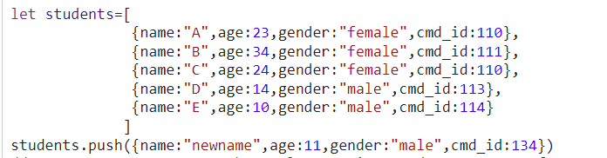

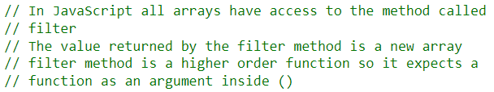



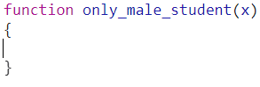



**Filter method calling function**  **once for each item in the array (students array):**

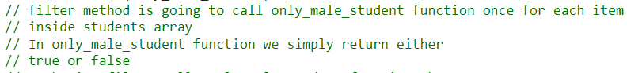



On every current call to the  function, current items of the array  is passed to the  function.

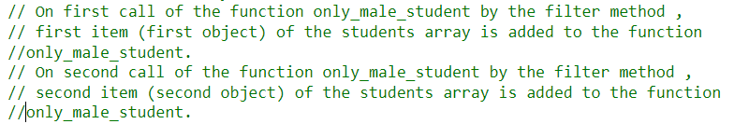

x is the current item inside the  array corresponding to the current call of the function by the filter method

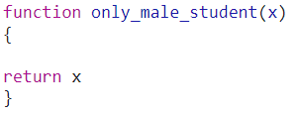

**Value returned by the filter method upon calling**  **function by filter method is an array:**



**Output:**

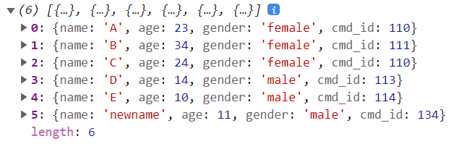



For those items of  array inside that gets into  function, condition is true gets added into new array that is returned by filter method.

For those items of  array inside that gets into  function, condition is false gets skipped.

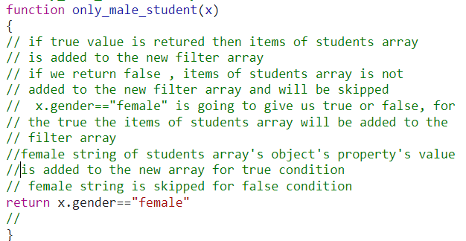

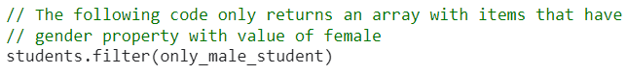

**Output:**

We see that three items of  array fulfill the condition and gets added into new array that is returned by filter method

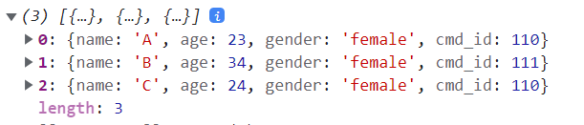

Like all array in JavaScript have access to the filter method hence similarly

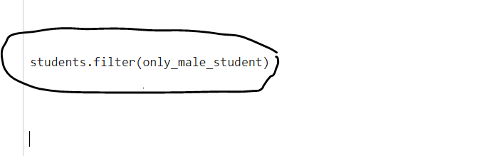

Is an array, it also has access to the method called filter



Filter is a higher order function hence it expects a function inside ()

Every time the  function is called by filter method by following code,



The items in the array  gets added into  function.

is the current item of the array  corresponding to the current function call of the  function by filter method.



On first function call by the filter method to the  function, first item of the array  is added to the function .

On second function call by the filter method to the  function, second item of the array  is added to the function .

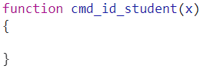

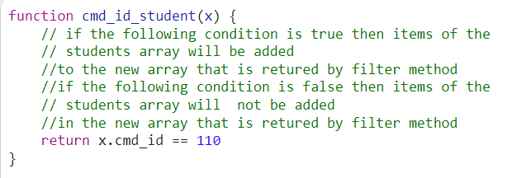



Output:

Only two items (Objects) fulfill the condition.

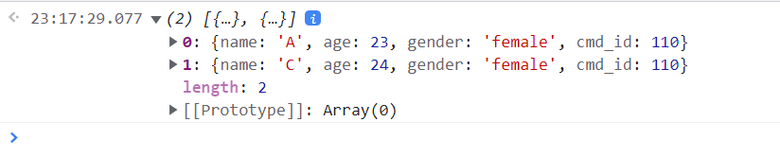

For the array to be further filtered

Creating a new function

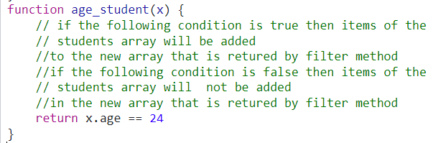

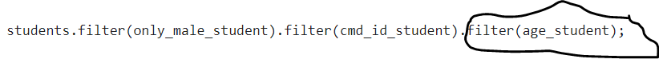

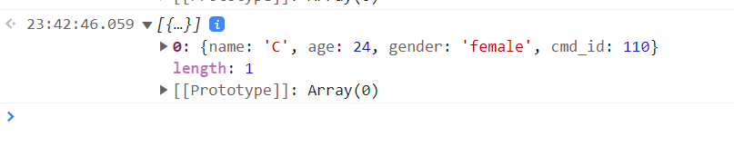

For the new array containing only value of the age property



Whatever is returned in  function, gets added in the new array that is returned by map method.

map method calls  function by following code.



and each time map method calls  function, it passes items of the  array into the  function, x is representing that current item corresponding function call to the  function.

On first function call , first item of the  array is into the  function.

